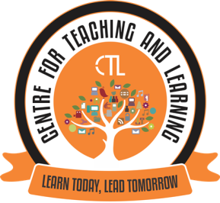

The Centre for Teaching Learning organised a workshop on ’Training programme on G suite for Non teaching staff’. In house training session was conducted on 20/11/2020 from 3.00pm to 4.30 pm. with an objective to assist the staff in their daily administrative work. The focus of this workshop was to give elementary exposure on functionalities of google drive such as google sheet, google doc and google forms. The staff was given hands- on training.
This training will help the participants in efficient data collection and document sharing.
The resource person for the training session was Ms Rupali Tamuly, Department of Economics of this college.
This was attended by 13 Non teaching staff members.

